EXPERIMENT NO. 06
IMPLEMENTATION AND ANALYSIS OF MULTIPLEXER USING CMOS TRANSMISSION GATES
―――――――――――――――――――――――――――――――――――――――――――――――――――――――
AIM
To implement and analyze a 4:1 Multiplexer using CMOS transmission gates in LT Spice.
SOFTWARE USED
LT Spice
CIRCUIT DIAGRAM
Gate-level logic diagram and CMOS transmission gate schematic:
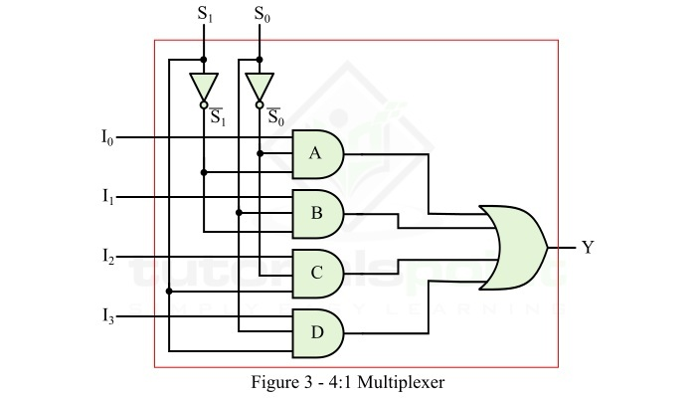
Figure 6.1: Gate-Level Logic Diagram of 4:1 Multiplexer
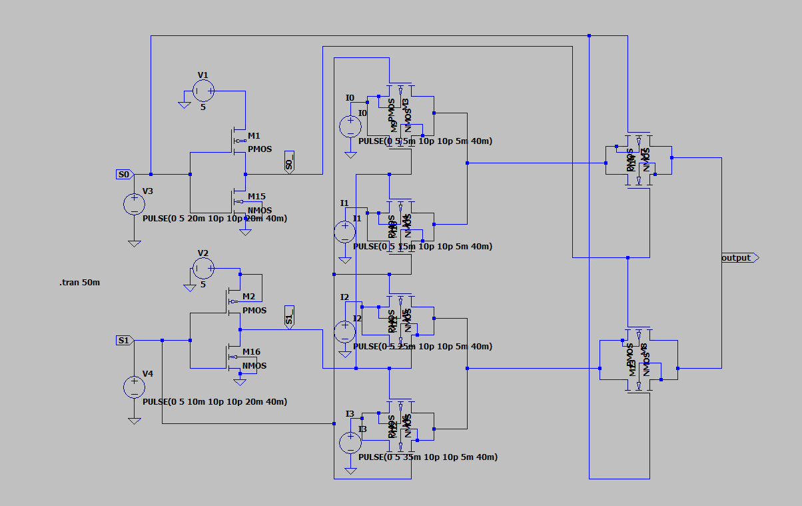
Figure 6.2: LT Spice Schematic of 4:1 MUX using CMOS Transmission Gates
SMALL THEORY
A 4:1 multiplexer (MUX) is a combinational data selector that routes one of four input lines (I0, I1, I2, I3) to a single output line Y, based on the digital control code applied to two select lines (S0, S1).
- Boolean Expression: Y = S1'·S0'·I0 + S1'·S0·I1 + S1·S0'·I2 + S1·S0·I3
- CMOS Transmission Gate: A CMOS transmission gate (TG) consists of an nMOS and a pMOS transistor connected in parallel, controlled by complementary gate signals. When enabled, both transistors conduct simultaneously: the nMOS transmits a strong '0' and the pMOS transmits a strong '1'. This overcomes threshold voltage degradation (VT drop) and delivers rail-to-rail signal passing with low dynamic on-resistance.
Function / Truth Table for 4:1 Multiplexer:
Select Line S1 | Select Line S0 | Selected Input | Output Y
0 | 0 | I0 | I0
0 | 1 | I1 | I1
1 | 0 | I2 | I2
1 | 1 | I3 | I3

OUTPUT GRAPH
Simulation waveform showing input data selection across all select line combinations:
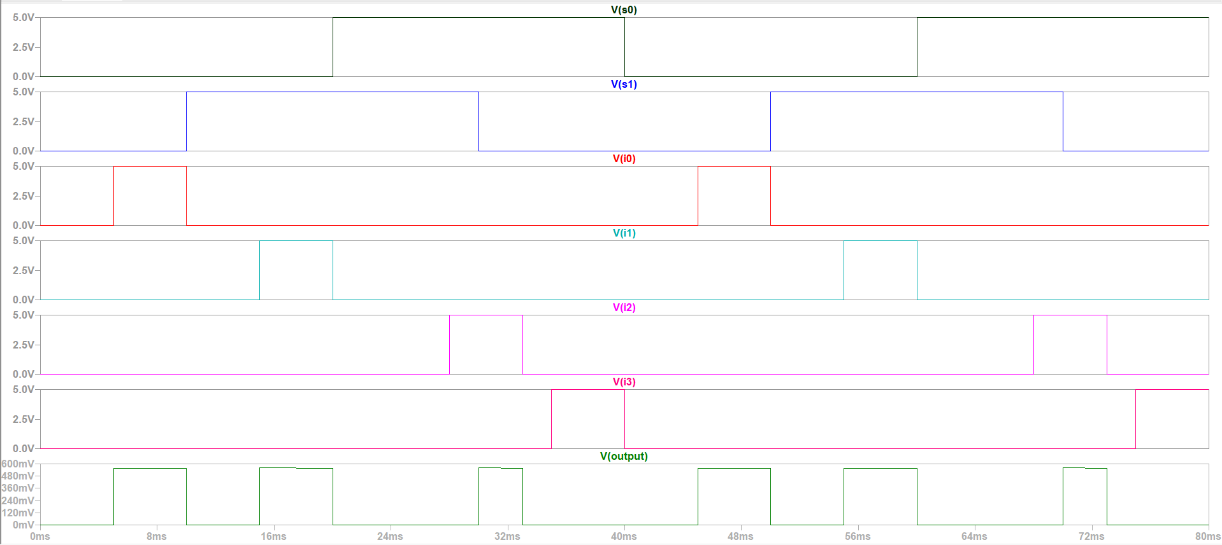
Figure 6.3: Simulated Waveforms for Select Lines (S0, S1), Data Inputs (I0-I3), and MUX Output

